# **OPTIMISING TIME-LIMITED NON-PHARMACEUTICAL INTERVENTIONS FOR COVID-19 OUTBREAK CONTROL**

## **ABSTRACT**

The introduction of non-pharmaceutical interventions (NPIs) to combat the ongoing COVID-19 outbreak have proven to be controversial, with physical, economical and mental health repercussions resulting from these measures. This has led to concept of intervention optimisation, which allows for policy makers to manage the duration, introduction and strength of NPIs, to minimise the human health effects from both the intervention and COVID-19. Here, we use epidemiological modelling to investigate the feasibility of optimising five different NPI scenarios, to minimise the human health repercussions in a simulated UK COVID-19 outbreak.

An optimal parameter space was identified to optimise all five NPI scenarios. However, these optimums were extremely narrow and therefore difficult to practically obtain. Greater focus should be placed on sub-optimal interventions which can still effectively mitigate human health impacts from COVID-19 over a wider parameter space and therefore give policy makers greater room for error. These suboptimal intervention strategies were identified for all considered NPI scenarios. This work provides a simple illustrative example of the concept of intervention optimisation across a wide range of different scenarios and serves as a basis for future in-depth modelling work.

## **INTRODUCTION**

Non-pharmaceutical interventions (NPIs) have been considered an invaluable tool during the ongoing COVID-19 pandemic. These interventions break chains in transmission through behavioural changes to reduce contact between individuals and reduce opportunities for transmission (**ref**). NPIs also encompass a large range of potential outbreak control strategies, ranging from simple advice to encourage hand-washing to country-wide stay-at-home orders, colloquially known as lockdown measures (**multiple ref**).

While an effective tool to drive down disease prevalence, lockdown measures are universally considered unsustainable and time-limited, with harsh economical, physical and mental health repercussions following the cessation of these interventions in early-2020 (**multiple ref**). This has driven calls to retrospectively understand the human health impact of introducing these lockdown measures under a different set of circumstances. This includes insight into how the differences in the timing, duration and strength of lockdown measures could have potentially reduced COVID-19 associated mortality and morbidity compared to the actual course of action (**multiple ref**).

Exploratory dynamic modelling into “optimising” NPIs and lockdown measures has arisen from these research questions (**multiple ref**). The concept of intervention optimisation is based on the ability to identify the course of action that can best mitigate the human health impacts of a disease outbreak. This focuses on intervention characteristics that are alterable by policy makers, such as the day at which the intervention is triggered, the duration and the magnitude of the intervention. The concept of sub-optimal or near-optimal interventions has also been explored, with an understanding that it may be it may not be possible to achieve these optimums in practice (**ref**). These analyses instead focus on identifying broad, easily achievable intervention strategies, that are not exactly optimal, but still capable of driving down COVID-19 associated mortality and morbidity

Interventions must also be optimised with regards to grounded and clinically/epidemiologically outcome measures that are relevant to the specific disease in question. As an example, reducing peak prevalence/incidence and “flattening the curve” has been identified as critical in reducing mortality during the COVID-19 pandemic (**ref**). This was borne out of hard lessons learnt during early outbreaks in Lombardy, Veneto and Wuhan, with the overwhelming of health services and ICU bed capacity having disastrous impacts on patient mortality (**multiple ref**).

Despite the existence of various strategies to introduce strong NPIs such as population lockdowns, we note that these intervention strategies are most often described in modelling literature as a constant reduction to transmission (**multiple ref**). In contrast to this, a number of intervention strategies have been proposed, allowing for the magnitude of an intervention to vary over time, with distinct “ramping” or “pulsing” periods (**multiple ref**). However, we note that there is a significant dearth of studies that explore the impact of these strategies on optimal and suboptimal intervention choice. These intervention strategies have been highlighted in recent COVID-19 literature as having a range of potential benefits over more traditional intervention measures and are therefore worthy of further exploration (**multiple ref**).

To gain a better understanding of these different intervention strategies and their resulting optimal and suboptimal parameter spaces, we conduct an exploratory mathematical modelling analysis to describe the existence and patterns of both optimal and suboptimal interventions to minimise either the maximum peak prevalence or total cumulative incidence. This was explored for three main parameters considered alterable by policy makers: 1) intervention duration, 2) intervention strength and 3) the date of the intervention trigger. We subsequently investigated the interplay between these parameters on model dynamics through a series of sensitivity analyses. We note that in a similar vein to previous COVID-19 modelling research, the results arising from this study are not intended as a framework to decide the best course of action (**ref**). Rather this analysis provides an illustrative example to describe how optimal and sub-optimal outbreak control can be achieved under different circumstances.

## **METHODS**

* 1. **SIR Model Structure**

A deterministic SIR model was used to explore the impact of time-limited non-pharmaceutical interventions (NPI) on a simulated UK-based COVID-19 outbreak. *S*, *I* and *R* compartments were used to denote the fraction of susceptible, infected and recovered individuals respectively within the population, with *S + I + R = 1* (**eqn 1.1**). The effects of demography were ignored for this model (births, deaths, migration, etc.).

$$\frac{dS}{dt}=-β(t)SI$$

$$\frac{dI}{dt}=β(t)SI-γI$$

$$\frac{dR}{dt}=γI$$

eqn 1.1

Susceptible individuals (*S*) are infected at the time-varying rate *β(t)*, which represents the daily per-capita rate of transmission in a randomly-mixing population. Infected individuals (*I*) recover at rate *γ*, representing the daily per-capita rate of recovery. This rate was taken as the inverse of the average duration of infectiousness. A baseline pre-NPI basic reproduction number (*R0*) of 2.8 and doubling time (*Td*) of 3 days were assumed, in line with reported estimates for COVID-19 transmission in the UK and abroad (**ref**). The generation time was calculated as a function of these two quantities (**ref**), with a baseline generation time of 7.79 days and a resulting *γ* of 0.128 (**eqn 1.2**).

eqn 1.2

* 1. **Defining the time-varying β(t)**

By setting *β = R0γ*, we define the baseline per-capita transmission rate in the absence of NPIs, *β = 0.359*. To capture the impact of small-scale NPIs (excluding population lockdown), *β* was multiplied by a scaling factor of 0.7, *βscale = 0.252*, with this 30% reduction being roughly in line with estimates of the impact of NPIs, such as school-closures, introduction of social distancing and isolation upon COVID-19 symptoms, and excluding lockdown measures. Using the UK as a representative example, these measures were introduced between 12-21st March 2020 with lockdown measures initiated on the 25th March 2020. We assume that these measures are in place at the initiation of the model simulation.

*β(t)* is defined as the product of *βscale* and a time-varying scaling factor *c(t)*, which reduces *βscale* over the course of the simulation to model the impact of lockdown measures, with *0 ≤ c(t) ≤ 1*. Reductions associated with this scaling factor are introduced on the lockdown trigger day, *tp*. This is defined as:

$$β(t)=\left\{\begin{aligned}β_{scale}, &t<t_{p} \\ {c(t)β}_{scale}, &t_{p}≤t≤t_{p}+d_{t} \\ β_{scale}, &t>t_{p}+d_{t}\end{aligned}\right.$$

The shape of *c(t)* varies with the different lockdown scenarios explored, with parameter *cmin* describing the minimum value of *c(t)* during the intervention. This can be considered a proxy measure of the magnitude of the intervention. This parameter ensures that for each considered intervention scenario, the same minimum value of *c(t)* and therefore *β(t)* is reached.

For baseline reductions to *β(t)* we define *cmin* = 0.4, resulting in *β*(t)= 0.101when the lockdown measures are at their greatest magnitude*.* Baseline *cmin* was chosen to roughly achieve an effective reproduction number (*Re*) of *0.7 ≤ Re ≤ 1* during lockdown, similar to that observed in COVID-19 literature, with *Re* defined as *R0S*. All lockdown interventions were initiated at baseline *tp* = 52 days, equivalent to a total cumulative infected fraction at the initiation of population lockdown, *Ic*(52)= 0.02, in line with model-based UK COVID-19 estimates (**ref**). The model was seeded with an initial infectious fraction, *I*(0) = 0.00001.

We note that *tp* = 52 days represents a significantly higher value compared to the UK intervention timeline (~13 days). However, with a sufficiently large initial infected fraction and with the model *tp* occurring at an epidemiologically accurate cumulative incidence, we note that the initial epidemic dynamics can be accurately captured, while simultaneously increasing model tractability, as it then becomes unnecessary to model the exact UK COVID-19 intervention timeline.

* 1. **Single Intervention Population Lockdown**

A time-limited population lockdown was the primary NPI explored in this model, with optimisation occurring in relation to this intervention. We explored five different lockdown strategies, with each intervention differing with regards to the shape of *c(t)* and the subsequent *β(t)* reductions over the duration of the intervention duration, defined as *dt* (**Table S1**). The model simulation was run for 400 days.

**Table 1** – Description of the five lockdown interventions.

|  |  |  |
| --- | --- | --- |
| Scenario | *c(t)* during the simulation | Definition of *c(t)* scaling parameter |
| 1 | Immediate and constant reduction to *cmin*. |  |
| 2 | Immediate reduction to *cmin* followed by a linear increase back to *c(t)* = 1. | $$c(t)=c_{min}+\frac{1-c_{min}}{d_{t}}(t-t_{p})$$ |
| 3 | Linear decrease to *cmin* followed by an immediate return to *c(t)* = 1. | $$c(t)=1-\frac{1-c_{min}}{d_{t}}(t-t_{p})$$ |
| 4 | Linear decrease to *cmin* at *dt*/2, followed by a linear increase back to *c(t)* = 1. | $$c(t)=\left\{\begin{aligned}1-\frac{1-c_{min}}{\frac{d_{t}}{2}}(t-t_{p}), &t_{p}≤t<t_{p}+\frac{d_{t}}{2} \\ c_{min}+\frac{1-c_{min}}{\frac{d_{t}}{2}}(t-t_{p}), &t_{p}+\frac{d_{t}}{2}≤t≤t_{p}+d_{t}\end{aligned}\right.$$ |
| 5 | A “pulsing” lockdown with immediate reductions to *cmin* between intervention intervals 0-21, 35-49 and 63-77 days (for an example total intervention duration, *dt* = 84 days). | $$c(t)=\left\{\begin{aligned}c_{min}, &t_{p}≤t<t_{p}+{0.167d}_{t} \\ 1, &t_{p}+0.167d_{t}≤t<t_{p}+{0.333d}_{t} \\ c_{min}, &t_{p}+0.333d_{t}≤t<t_{p}+{0.5d}_{t} \\ 1, &t_{p}+0.5d_{t}≤t<t_{p}+{0.667d}_{t} \\ c_{min}, &t_{p}+0.667d_{t}≤t<t_{p}+{0.833d}_{t} \\ 1, &t≥t_{p}+{0.833d}_{t}\end{aligned}\right.$$ |

For a total length of intervention duration, *dt*, the magnitude of *c(t)* scaling reductions over the intervention period is half for scenario 2, 3, 4 and 5 relative to scenario 1. To maintain comparable overall *β(t)* reductions over the intervention period, *dt* was doubled for scenario 2, 3, 4 and 5 relative to scenario 1 for baseline analyses. This corresponds to *dt* = 84 days for scenario 1 (12 weeks) and *dt* = 168 days (24 weeks) for all other scenarios. An alternative approach was considered by keeping *dt* constant and doubling *cmin* reductions observed in scenario 2, 3, 4 and 5 relative to scenario 1 (**Figure S1 + 2**). Either method is plausible when considering potential intervention scenarios, but we argue that in practice it is more plausible to alter *dt* than it is to alter *cmin* in a public health context.

* 1. **Multiple Intervention Population Lockdowns**

To explore the transmission dynamics resulting from multiple time-limited lockdown masures, two interventions were modelled sequentially over the course of the simulation. The generic shape of *c(t)* reductions for the five different lockdown scenarios were kept constant for both intervention 1 and 2 (**Table S2**). We define the minimum value of the lockdown-related *c(t)* scaling factor, lockdown trigger point and duration of the intervention as *cmin1*/*cmin2*, *tp1*/*tp2*, and *dt1*/*dt2* respectively for intervention 1 and 2. We highlight that *tp2* is defined relative to the end of intervention 1, with the exact start of intervention 2 defined as *t* = *tp1* + *dt1* + *tp2*.

Baseline *dt1*  and *dt2* for multiple interventions were halved relative to the single intervention scenarios to ensure that the interventions could occur within the timeframe of the simulated epidemic curve. Similar to the single intervention scenario, the intervention duration of scenario 2, 3, 4 and 5 were doubled relative to scenario 1 to ensure comparable magnitudes of *β(t)* reductions over the intervention period. Baseline parameter values for the multiple intervention scenario were set at *dt1* = *dt2* = 42 days (6 weeks) for scenario 1 and *dt1* = *dt2* = 84 days (12 weeks) for scenarios 2, 3, 4 and 5. The minimum value of lockdown-related scaling factor *c(t)* was kept static at baseline for both interventions at *cmin1* = *cmin2* = 0.4. The model simulation was run for 730 days.

* 1. **Outcome Measures of Interest**

The primary objective of all analyses in this study was to identify the optimal parameter space for the intervention trigger point (*tp*), duration (*dt*) and magnitude (cmin) to minimise the values of two outcome measures:

1. Maximum peak prevalence *I(t): Imax*
2. Total cumulative incidence: $I_{c}\left(∞\right) =\lim_{t→∞}{I_{c}(t)}$

We define *Imax* as the global maximum of the function describing the trajectory of the epidemic, with subsequent references to “epidemic peaks” describing the local maximums where *I(t) > 0* and *I’(t) = 0*. The optimal parameter is defined as the combination of parameter values that result in the lowest possible value of *Imax* or *Ic(∞)* in the explored parameter space.

1. **Software Used**

All model simulations were carried out using R (v3.6.2) and Rstudio. The following packages were used for all R-based simulations and plotting: “*desolve*” (v1.28), “*ggplot*2” (v3.3.2), “*reshape2*” (v1.4.4) and “*ggpubr*” (v0.4.0).

**RESULTS**

Trajectory plots were explored to assess the impact of the five different lockdown measures on the trajectory of a COVID-19 epidemic curve (**Figure 1A**). Alterations in *β(t)* and *Re* were also identified, with all scenarios compared to an unmitigated epidemic using baseline parameters. Scenario 1 and 2 resulted in the suppression of the epidemic following the initiation of lockdown measures, with a resurgent 2nd peak occurring after the cessation of the intervention and with Re > 1. This can be attributed to the large pool of remaining susceptibles following the cessation of the intervention, due to strong initial lockdown measures. In contrast, a single mitigated epidemic peak was observed for scenario 3 and 4 due to the effects of population immunity and “ramping up” of *β(t)* reductions, gradually suppressing *Re* < 1 for the remainder of the simulation. The pulsed nature of scenario 5 allowed for brief opportunities for the build-up of population immunity (*Re* > 1) and subsequent epidemic control (*Re* < 1).

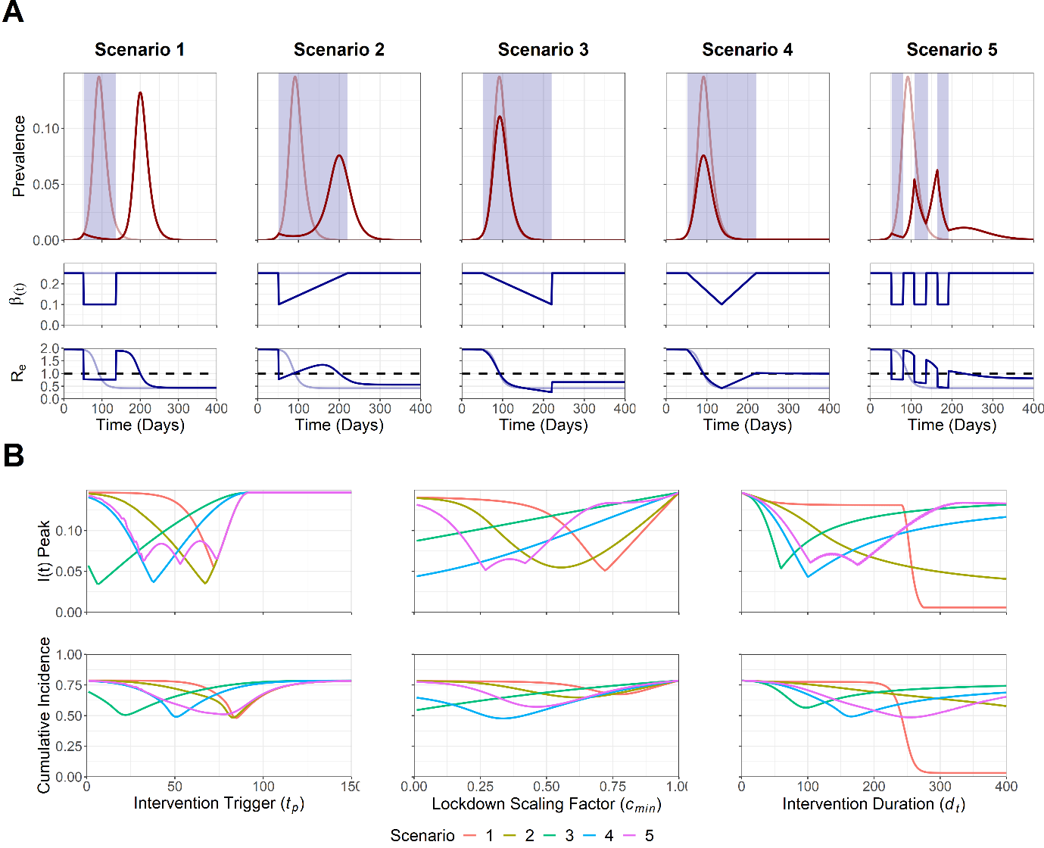

**Figure 1. A) Trajectory plots for the epidemic curve, *β(t)* reductions and *Re* for the five intervention scenarios. B) Sensitivity analysis for Intervention trigger day (*tp*), magnitude of lockdown measures (*cmin*) and intervention duration (*dt*) to minimise maximum *I(t)* peak, *Imax*, and total cumulative incidence, *Ic(∞)*.** Note that for A) opaque red and blue lines in the trajectory plot depict unmitigated epidemic curve dynamics.Blue shading indicates the period of the intervention. Dotted line on the *Re* plot denotes the threshold for sustained epidemic growth.Note that for B) scenarios are comparable for a specific explored parameter value, with the duration of scenario 2, 3, 4 and 5 being doubled to ensure similar intervention magnitudes across all scenarios. This was not possible for the intervention duration sensitivity analysis, as the parameter value remains fixed for a specific explored value of *dt*.

Sensitivity analyses were also conducted to observe the sensitivity of the maximum *I(t)* peak, *Imax*, and the total cumulative incidence, *Ic(∞)* to the intervention trigger day (*tp*), magnitude of lockdown measures (*cmin*) and intervention duration (*dt*) parameters (**Figure 1B**). Each sensitivity analysis was conducted with all other parameters held at baseline levels. A range of low-intermediate optimal trigger points (7 ≤ *tp* ≤ 74) to minimise *Imax* were identified across all five scenarios. These optimums were highly sensitive to suboptimal deviations from the optimal *tp* value for scenario 1, 2, 3 and 4, with steep increases observed in *Imax*. This suggests that intervening too early/late makes little difference in the context of preventing increases in *Imax* and *Ic(∞)* with a poorly timed, suboptimal intervention. In contrast, an early intervention was more beneficial to minimise *Imax* and *Ic(∞)* for scenario 3, and with a large range of optimal trigger points being observed for scenario 5 (32 < *tp* < 74).

Stronger interventions were found to be more optimal to minimise *Imax* and *Ic(∞)* for scenario 3 and 4. In contrast, scenario 1, 2 and 5 were able to optimally minimise both outcome measures using an intermediate strength intervention (0.27 ≤ *cmin* ≤ 0.72). We note that despite the optimums observed for scenario 1, 2 and 5, it was still more beneficial to intervene too strongly than insufficiently, with lower suboptimal *cmin* values being more capable of minimising *Imax* and *Ic(∞)*, compared to suboptimal values of *cmin* which were too high. Longer intervention durations were found to be optimal to reduce *Imax* and *Ic(∞)* for scenario 1 and 2. Intermediate length interventions were found to be optimal for all other scenarios (60 ≤ *dt* ≤ 175). However, we note that if a suboptimal intervention duration is introduced, it is more beneficial to intervene for too long, with increases in *Imax* and *Ic(∞)* being less severe in an intervention that is longer than optimal, compared to an intervention that is shorter than optimal.

To explore the interplay between multiple model parameters, a sensitivity analysis was next conducted to identify the optimal parameter space to minimise *Imax* and *Ic(∞)* for a multi-dimensional parameter space: 1) Intervention trigger day (*tp*) and 2) Intervention duration (*dt*) (**Figure 2**).

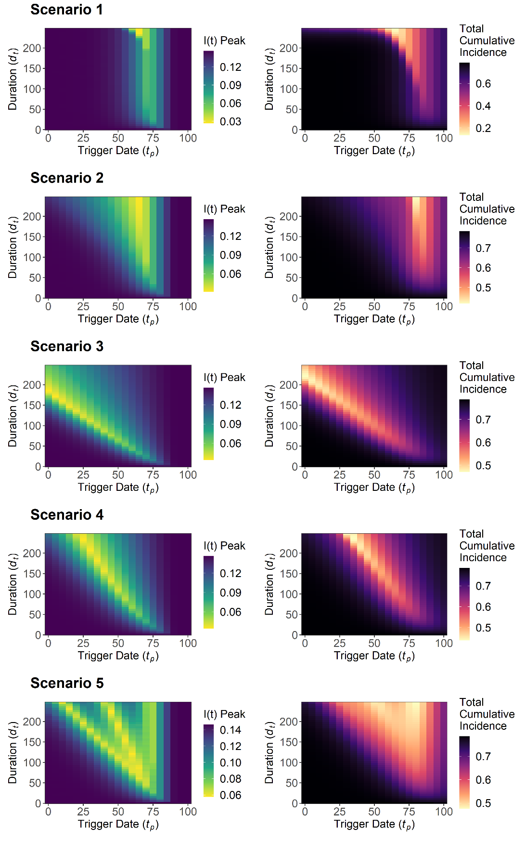

**Figure 2. Sensitivity analysis for maximum *I(t)* peak, *Imax*, and total cumulative incidence, *Ic(∞)*, for intervention trigger day, *tp*, and the intervention duration, *dt*. This was explored for the five intervention scenarios.** Note that for a specific value of *dt*, scenario 1 is not comparable with scenario 2, 3, 4 and 5 due to the need to double *dt* for the latter scenarios to ensure a comparable intervention magnitude over the intervention duration. This is not possible for this sensitivity analysis with *dt* being a fixed explored parameter and heatmap legends will differ across scenarios.

A long intervention duration (*dt* > 200) and an intermediate trigger point (*tp* = 65) was optimal for scenario 1 and 2 to minimise *Imax* and *Ic(∞)*. However, once the optimal intervention trigger was achieved, a large range of intervention durations could be used with negligible impact to either outcome measure (10 ≤ *dt* ≤ 200). A different qualitative pattern was observed in scenario 3 and 4, with decreases to the intervention duration being necessary to maintain the optimal parameter space with a later intervention trigger. Rough qualitative agreement was found between the overall optimal parameter space for both outcome measures across all scenarios.

Increasing the length of the intervention was found to compensate for suboptimal choices of the intervention trigger in scenario 2, 3, 4 and 5, with both *Imax* and *Ic(∞)* being less sensitive to suboptimal deviations from the optimal intervention trigger point as the duration of the intervention was increased. We also note the existence of suboptimal trigger point “gaps” in scenario 5, with increases and decreases in *Imax* as the trigger point was varied. This resulted from the fixed periods between pulsed interventions, with these “gaps” increasing as the duration of the overall intervention increased. This was found to be less pronounced for *Ic(∞)* relative to *Imax*.

The sensitivity analysis was repeated with *cmin* = 0.25/0.5/0.75 to assess the sensitivity of the *dt*/*tp* relationship to alterations to the magnitude of the intervention (**Figure S3 + 4**). Low-intermediate *cmin* values of 0.25 (scenario 1, 2 and 3) and 0.5 (scenario 3 and 4) were found to be more optimal to minimise *Imax*, with the lowest explored value of *cmin* being optimal to minimise *Ic(∞)* for all scenarios.

Two sequentially implemented lockdown measures were introduced for each of the five scenarios to explore the impact of multiple interventions on the trajectory curve of the simulated COVID-19 epidemic (**Figure 3**). Alterations in *β(t)* and *Re* were also identified.

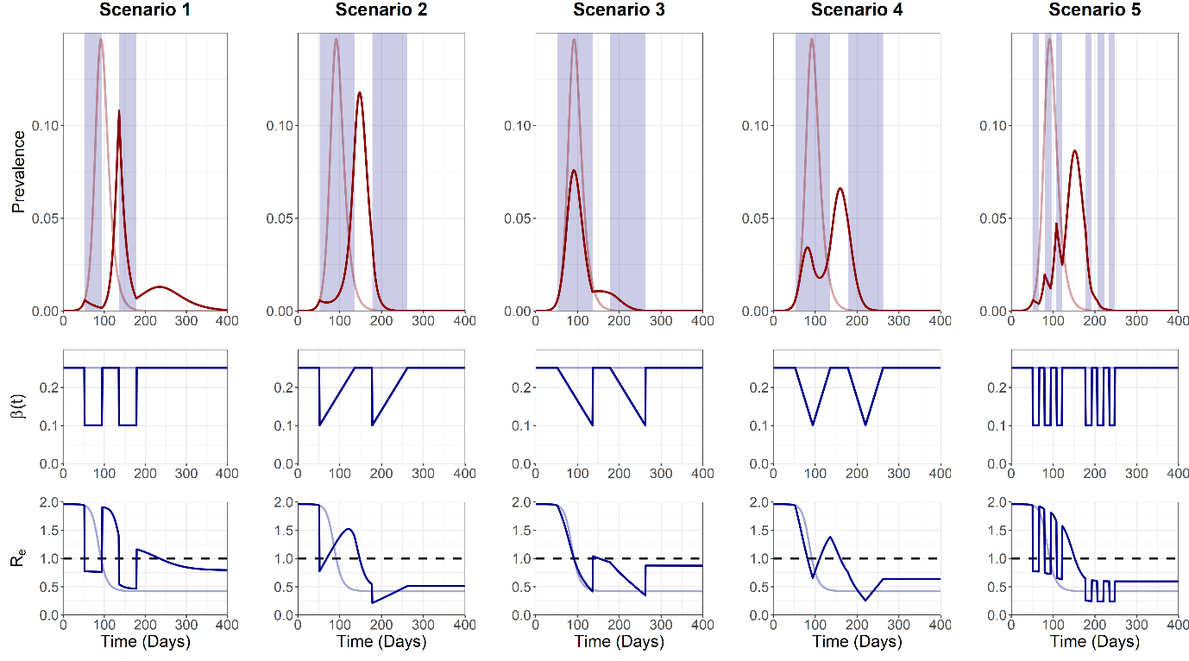

**Figure 3. Trajectory plots for the epidemic curve, intervention associated R0 reductions and Re, for the five “double” intervention scenarios.** Opaque red and blue lines depict unmitigated epidemic curve dynamics.Blue shading on the trajectory plot indicates the period of the intervention. Dotted line on the *Re* plot denotes the threshold for sustained epidemic growth.

We note the occurrence of a large second epidemic peak in scenario 1 and 2, with *Re* increasing substantially above 1 between interventions. A third epidemic peak was also observed due to the strong *β(t)* reductions imposed by scenario 1, with *Re* > 1 occurring transiently after the cessation of the second intervention. Scenario 3 and 4 were characterised by the suppression of epidemic peaks, with *Re* unable to increase above 1 for a sufficient period of time to cause a sustained increase in prevalence following the cessation of the intervention. Scenario 5 displayed similar dynamics to the single intervention scenario, with controlled reductions to *β(t)* preventing a sustained increase in *Re* > 1.

A sensitivity analysis was next conducted with the multiple intervention model to explore the optimal parameter space to minimise *Imax* and *Ic(∞)* for two sets of parameters: 1) Intervention 1 trigger date, *tp1*, and Intervention 2 trigger date, *tp2,* and 2) Intervention 1, *cmin1*, and Intervention 2, *cmin2* (**Figure 4**). As with previous analyses, the optimal parameter space for both sets of interventions was explored to minimise *Imax* and *Ic(∞)* outcome measures.

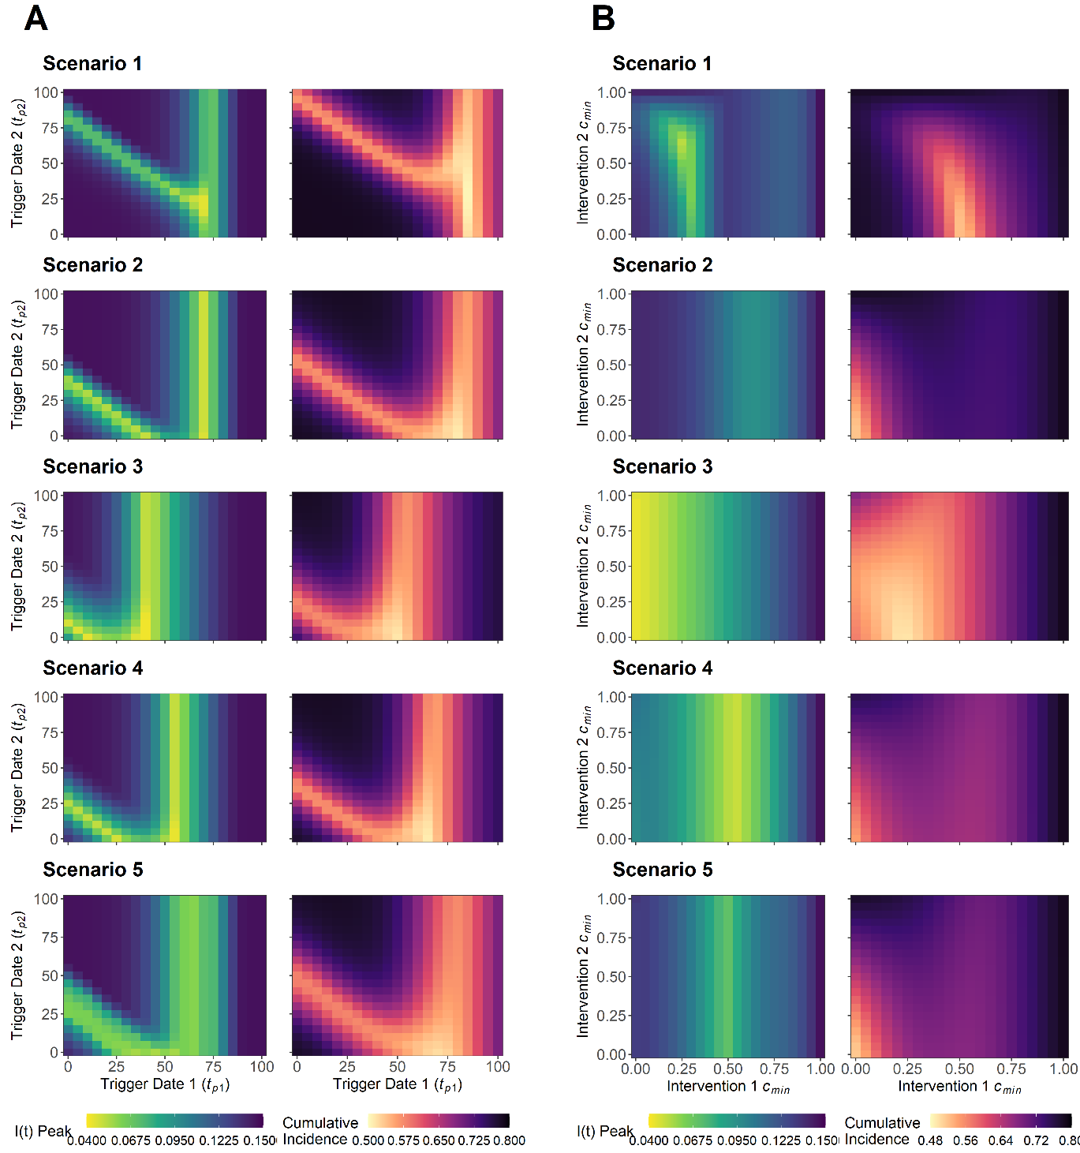

**Figure 4. A) Sensitivity analysis for maximum I(t) peak, *Imax*, and total cumulative incidence, Ic(∞), for intervention 1 trigger date, *tp1*, and intervention 2 trigger date, *tp2*. This was explored for the five intervention scenarios. B) Sensitivity analysis for the minimum value of lockdown-related scaling factor *c(t)* for intervention 1, *cmin1*, and intervention 2, *cmin2*.** This was explored for the five intervention scenarios. To ensure comparable overall magnitude of interventions of over the intervention duration, the *dt1*/*dt2* value of Scenarios 2, 3, 4 and 5 were doubled relative to scenario 1 (12 vs 6 weeks). All scenarios are therefore comparable for a given parameter value combination with heat map legends remaining constant for each set of explored parameters.

A large range of trigger points for intervention 2 (1 ≤ *tp2* ≤100) were optimal to minimise *Imax* and *Ic(∞)*, on the condition that the optimal trigger point for intervention 1 was achieved (*tp1* = 65) (**Figure 4A**). This was found to differ if a suboptimal *earlier* intervention 1 trigger point was chosen, with only a narrow selection of optimal intervention 2 trigger points able to compensate for the suboptimal *tp1* value. The choice of a *later* than optimal intervention 1 trigger was found to completely negate the ability for an intervention 2 trigger to prevent increases in *Imax* and *Ic(∞)*, suggesting that it is better to introduce the initial intervention earlier, rather than later, if the optimal intervention 1 trigger point is unknown. Extending the duration of intervention 1 and 2 did little to alter the optimal trigger points for either scenario (**Figure S5-14**).

Optimising the magnitude of intervention 1 was found to be more critical to minimise *Imax* and *Ic(∞)*, with a large range of optimal magnitudes possible for intervention 2 (0 ≤ *cmin2* ≤ 1) if the magnitude of intervention 1 is sufficiently optimised (**Figure 4B**). Scenario 1, 2, 4 and 5 were characterised by an intermediate optimal intervention 1 magnitude (0.25 ≤ *cmin1* ≤ 0.65). Scenario 3 displayed subtly different dynamics, with intervention 1 ideally being as strong as possible (*cmin1* → 0) to optimise reductions to both *Imax* and *Ic(∞)*. Increases in the duration of intervention 1 allowed for greater reductions to *Imax* and *Ic(∞)* for a given *cmin1*/*cmin2* parameter space, relative to baseline parameters (**Figure S15-24**). The exception was scenario 3, with increases in intervention 1 duration resulting in detrimental increases to possible *Imax* and *Ic(∞)* values for a given combination of *cmin1*/*cmin2*.

## **DISCUSSION**

This work builds on previous epidemiological modelling to explore the optimal parameter space to minimise maximum peak prevalence (*Imax*) and total cumulative incidence (*Ic(∞)*) across five different intervention scenarios (**multiple ref**). This was explored in the context of population lockdown measures and a simulated COVID-19 outbreak. We note that there is no single intervention strategy that can be considered the most optimal approach, with each scenario capable of minimizing both *Imax* and *Ic(∞)* for a given set of unique, optimal parameter values.

The optimal parameter space to minimise *Imax*, and to a lesser extent *Ic(∞)*, for each intervention scenario can be attributed to two key characteristics: 1) Intervention peak timing and 2) Intervention *cmin* balance. Matching the timing of an intervention to the epidemic peak is not a novel concept and has been explored previously (**ref**). However, we demonstrate that it is also necessary to match the timing of the epidemic peak with the greatest extent of the intervention (*cmin*/*cmin1*/*cmin2*) if reductions to *β(t)* are allowed to vary. This can be intuitively observed by comparing scenario 2 (*cmin* at *tp*) and scenario 3 (*cmin* at *tp* + *dt*) (**Figure 2**), with scenario 2 being optimal at a later trigger day to coincide with the early *cmin* reduction and scenario 3 optimal with an earlier intervention trigger to coincide with the later *cmin* reduction. Additionally, as highlighted by previous modelling (**ref**), it is also necessary to balance the intervention strength, to prevent an unmitigated epidemic due to an insufficient intervention, or the maintenance of population susceptibility due to an intervention that is too strong.

As highlighted by previous research, achieving these optimums in practice is likely to be difficult (**ref**). A combination of narrow parameter optimums, imperfect disease surveillance, confounding parallel interventions, public compliance, an inability to fine tune the strength of an intervention and a lag between the introduction of an intervention and observable alterations in the disease prevalence, would likely prevent policy makers from micromanaging the course of a COVID-19 outbreak to minimise *Imax* and *Ic(∞)* (**multiple ref**). It is therefore more relevant to focus on the viability of suboptimal interventions, to identify a generic intervention course that can still somewhat minimise *Imax* and *Ic(∞)*.

We note that for a single time limited intervention, the most effective suboptimal strategy to reduce *Imax* and *Ic(∞)* can be achieved by intervening stronger and for longer than what is considered optimal (**Figure 1 + 2**). For multiple time-limited interventions, it was more beneficial to focus efforts on managing the initial intervention, with subsequent interventions only able to compensate for a suboptimal initial intervention under a narrow range of circumstances (**Figure 4**). Increasing the strength and introducing this initial intervention earlier would therefore be more optimal to reduce *Imax* and *Ic(∞)* under suboptimal circumstances.

We note that intervention measures such as population lockdown are widely recognised as unsustainable, with detrimental economical, physical and mental health impacts (**multiple ref**). As evidenced by the ongoing COVID-19 outbreak, these measures are often not considered in isolation, instead used as an integral part of a wider strategy to drive down the level of infection and buy time for the development introduction of more sustainable measures, such as test, track and trace or vaccination (**multiple ref**). We note that in this context, it universally more optimal to introduce the initial lockdown measures earlier, more strongly and for as long as necessary, until more sustainable intervention measures can be introduced indefinitely (**Figure S25**) (**ref**). The rationale behind this approach is to essentially use the initial lockdown measures to “buy time” and prevent increases in *Imax* and *Ic(∞)*, before the introduction of more sustainable secondary intervention that can effectively suppress both outcome measures. While we note that this corroborates some of the suboptimal strategies to minimise *Imax* and *Ic(∞)*, there are also substantial differences. This highlights the importance of identifying the questions posed by policy makers when considering either suboptimal or optimal epidemic control (**ref**).

In contrast to the SIR model structure used by this study, we note that an SEIR framework could be considered more accurate to describe the epidemiological characteristics of SARS-COV-2 (**multiple ref**). This model structure alteration would manifest as a delay between the intervention and observed effects in *I(t)* (**multiple ref**). However, this was considered unnecessary, with the aim of this study to describe the existence and patterns of intervention optimums, and not describe the exact timing. We also note that the addition of this compartment would likely increase the number of assumptions underlying the model, with both the infectious and an incubation period possessing implicitly assumed exponentially distributed waiting times (**multiple ref**). However, we note that this could be resolved through the use of Erlang or gamma distributed waiting times in future analyses (**multiple ref**).

An assumption of life-long immunity was also assumed following SARS-COV-2 infection. This choice was made due to the large amount of uncertainty regarding the immunological characteristics of the virus, which is currently under debate (**multiple ref**). **However, this could be explored in future models – the effect of pre-existing immunity.** A relatively simple disease metric was also used for this study, with an optimal intervention able to reduce maximum peak prevalence, *Imax*, and total cumulative incidence, *Ic(∞)*. While outside of the scope of this study, the use of more epidemiologically relevant outcome measures such as occupied ICU capacity or deaths per 100,000 population may be of interest when investigating optimal COVID-19 interventions in a more policy-relevant context (**multiple ref**). This could also be complemented by an exploration into the impact of individual or population level variation of risk on intervention optimisation. For example, investigating intervention optimisation in the context of a realistic age-structured population or with regards to the impact of individual-level overdispersion in transmission (**multiple ref**).

Although we describe the possibility of optimising various intervention strategies throughout this study, it was not the intention to propose this as a singular solution for COVID-19 epidemic control. The results described in this study are highly nuanced, with narrow intervention optimums and a number of other factors likely preventing the trajectory of an epidemic conforming uniformly to the dynamics observed in this study. Instead, it is of greater interest to identify potential benefits from more easily achievable suboptimal interventions that can still successfully minimise epidemiologically relevant outcome measures. This has the additional benefit of being a risk-averse approach, which is often favourable during the initial stages of the outbreak, where the potential impact of risky public health policy can lead to disastrous consequences. Finally, we note that the evidence from this study should be taken into context with the work tirelessly undertaken by the wider epidemiological and modelling community. It is only through this collaboration and synthesis where effective and humanistic public health policy can be generated to combat the COVID-19 pandemic.